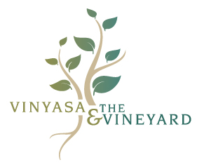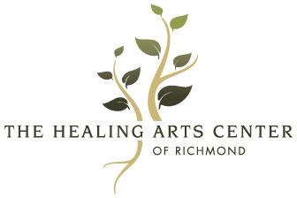

AGREEMENT OF RELEASE AND WAIVER OF LIABILITY

I, _____________________________, hereby agree to the following:

1. That I am participating in the Yoga Classes, as well as other exercise fitness routines, Health Programs or Workshops/Retreats offered by The Healing Arts Center of Richmond, PLLC/Katherine Meyersohn, LCSW, RYT-500 (herein referred to as The Healing Arts Center of Richmond) during which I will receive information and instruction about yoga, fitness, and health. I recognize that yoga, and other exercise fitness routines require physical exertion that may be strenuous and may cause physical injury, and I am fully aware of the risks and hazards involved.

2. I understand that it is my responsibility to consult with a physician prior to, and regarding my participation in
Yoga Classes, as well as other exercise fitness routines, Health Programs, or Workshops/Retreats offered by The Healing Arts Center of Richmond. I represent and warrant that I am physically fit and I have no medical condition that would prevent my full participation in the Yoga Classes, as well as exercise fitness routines, Health Programs or Workshops/Retreats. I understand that it is my responsibility to update this waiver with regard to any health condition changes that I experience in the future.

3. In consideration of being permitted to participate in Yoga Classes, as well as exercise fitness routines, Health Programs or Workshops/Retreats, I agree to assume full responsibility for any risks, injuries or damages, known or unknown, which I might incur as a result of my participation.

4. In further consideration of being permitted to participate in Yoga Classes, as well as exercise fitness routines, Health Programs or Workshops/Retreats, I knowingly, voluntarily and expressly waive any claim I may have against The Healing Arts Center of Richmond for injury or damages that I may sustain as a result of participating in the program, and as a result of my negligence in participating in this activity.

5. I understand that complementary therapies including Energy Psychology, GIM (The Bonny Method of Guided Imagery & Music), Reiki, and The MARI (Mandala Assessment Research Instrument), like other healing arts, are not exact sciences and that no guarantees are being made as to the result of their use and practice.

6. I, my heirs, and/or legal representatives forever release waive, discharge and covenant not to sue The Healing Arts Center of Richmond, PLLC/Katherine Meyersohn, LCSW, RYT-500 for any injury or death caused by their negligence or other acts.

I have read the above release and waiver of liability and fully understand its contents. I voluntarily agree to the terms and conditions stated above. I realize there are special risks that could be associated with pregnancy, prior surgeries, injuries, and medical conditions that may carry additional health concerns. I have discussed these with my personal physician, and I have obtained his or her concurrence to participate in activities offered by The Healing Arts Center of Richmond. I fully understand that The Healing Arts Center of Richmond, PLLC/Katherine Meyersohn, LCSW, RYT-500, instructors and staff are not medically trained physicians or experts in medicine, and therefore, realize that their guidance is limited to the practice of yoga and fitness exercise, and the techniques and routines associated with them.

This agreement shall be governed by the laws of the Commonwealth of Virginia.

I am not relying on any oral, written, or visual representations or statements made by The Healing Arts Center of Richmond, including brochures or promotional materials to induce me to participate in this activity.
I have read the above release and waiver of liability and fully understand its contents. I voluntarily agree to the terms and conditions stated above.

__________________________________________________ _______/_______/______
SIGNATURE OF PARTICIPANT DATE

__________________________________________________
PRINTED NAME OF PARTICIPANT

WITNESSED BY: ___________________________________ _______/_______/______
DATE

2117 W. Main St., Richmond, VA 23227
TheHealingArtsCenterofRichmnd.com 804-833-8776

